App installation Guide:

1-Launch Xampp and import the mysql database I have provided inside the htdocs.zip(ct.sql) file.

2-Make sure you're using android 7 or below.

3-Go to the Google Playstore and install nativescript playground, and nativescript preview.

1- https://play.google.com/store/apps/details?id=org.nativescript.play&hl=en

2- https://play.google.com/store/apps/details?id=org.nativescript.preview&hl=en

4-Get your local ip address by running ipconfig in the windows command line:

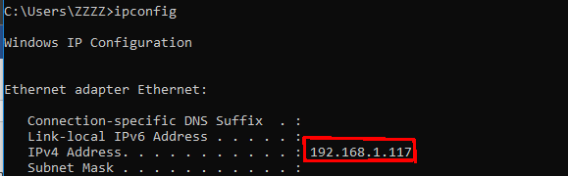

5-Now copy your local ip in the following files/applications.

1-m.js

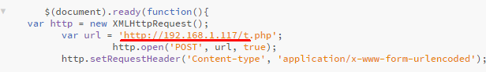

2-mbikes.js

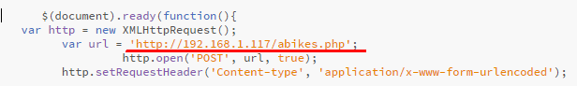

3.Go to <https://play.nativescript.org/?template=groceries-ng&id=h1Ju2o&v=101> and navigate to the shared folder. Click on config.ts and change apiUrl to your local ip address

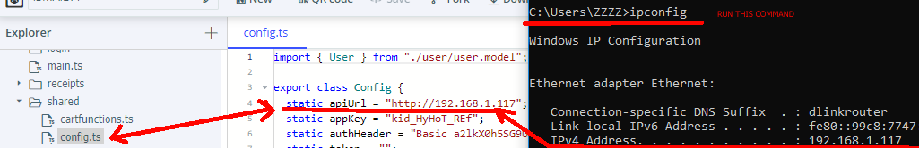

6- Now on the site click on save then QR code.

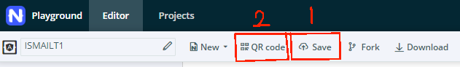

7-Open the nativescript playground app and scan the QR code on screen.

8-Done!

9-You can login with the default user provided with the password “password”.

3-Alternatively navigate to the NSPlaygroun.zip provided and extract it.

4-navigate to the extracted folder and go into app>shared>shared.ts and change the ip to your local ip address.

5-now navigate to NSPlayground folder with the command terminal and run the following commands:

1-npm install -g nativescript@latest and wait for completion.

2-tns preview

6- A QR code should have a appeared-on screen, scan it with the app similar to before.